*1985 AICHE Project: Styrene from Toluene and Methanol*

Link found here: (<https://www.aiche.org/sites/default/files/node/aiche-student-design-competition/1985-StudentDesignContent-Styrene-From-Toluene-and-Methanol_0.pdf>)

**Introduction:**

Styrene is currently produced from an endothermic process, alkylated benzene into ethylbenzene. Where the ethylbenzene is dehydrogenated via catalyst into styrene monomer with steam. However high temperature and pressure steam can cause coking to occur on the catalyst, thus dilutions of the reactant composition must be made in order to improve the equilibrium. New research has shown the synthesis of styrene from toluene and methanol via a catalyst in a single reaction. With this in mind, an opportunity to develop a new process for such a reaction could enhance the efficiency and broaden the market for styrene manufacturing.

*\*It is important to note that the current process with ethylbenzene can be found in Appendix B of Turton!*

***Reaction in consideration…***

*Desired Reaction:*  Toluene + Methanol ⇋ Styrene + Water + Hydrogen

C7H8 + CH3OH → C8H8 + H2O + H2

*Side Reaction:*  Toluene + Methanol ⇋ Ethylbenzene + Water

C7H8 + CH3OH → C8H10 + H2O

**Feed Preparation:**

The reaction is to take place under saturated vapor conditions at around 570 KPa for both the feed of MeOH and Toluene. This indicates the following for feed preparation:

1. Compress initial feed assuming STP.
   1. If we consider recycling we would need a hold vessel after this stage.
2. Vaporize compress feed to desired reacting pressure.
3. Mix both streams in a heating furnace, before feeding into a catalytic reactor.

Toluene should be our limiting reactant since separating methanol would be easier as a recycling method!

The costs as given in Table 8.4:

* $0.672/kg for MeOH
* $1.033/kg for toluene
* $1.598/kg for styrene

**Reactor/RXN:**

As indicated previously, this reaction requires a catalyst! As such we must choose between different reactor types, some of which we have covered in previous CHEME courses such as 465: Reactor Design.

* Plug Flow Reactor
* Pack-bed reactor
* Catalyst pellet reactor

Below are some data concerning different reacting conditions…

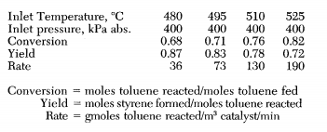

**Figure 1**: Operating condition data for the reaction of interest.

For the following materials from Table 7.9:



Toluene and MeOH are acceptable for all these materials with no temperature restrictions.

**Separation Prep:**

After the reaction has occurred the main products need to be condensed. Keep in mind that methanol and water produces an aqueous solution with organics as our main bulk. This means that we can at least achieve separation from polarity between water/methanol and ethylbenzene/toluene/styrene/hydrogen from the use of a stripper.

1. Condense the product gas streams
2. Separate hydrogen via a flash, the product of this will become our main separation fluid.

**Separation Process:**

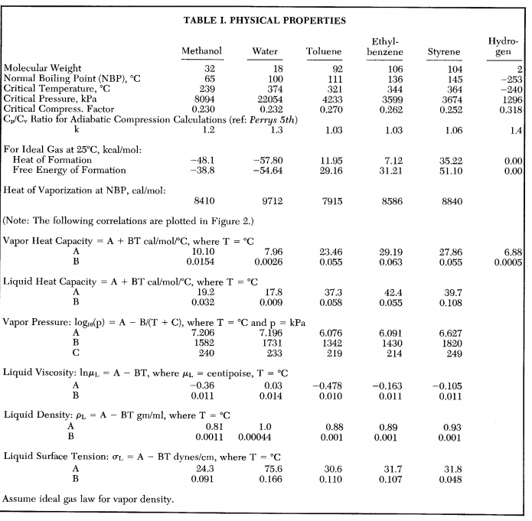

**Figure 2:** Thermodynamic data concerning our product stream.

It is important to keep in mind that the relative volatility of styrene and ethylbenzene are very close to each other.

* Normal BP of Styrene: 276.8 F/ 136 C
* Normal BP of Ethylbenzene: 293 F/ 145 C

This suggests either a multistep distillation process or some type of absorption/stripper method.

Recycling methanol back into the feed should be considered. As such separating water from MeOH might become a priority since excess water can shift the reaction equilibrium to the left. Additionally, the cost of MeOH is relatively high in comparison to our revenue from the styrene.

* Normal BP of Methanol: 148.5 F/ 64 C
* Normal BP of Water: 212 F/100 C

Large volatility suggests either flash separation or trayed-distillation! Whichever is less energetically intensive would be desirable!

Additionally, separating the initial product stream after gassing off the hydrogen can be done by a stripper. That is, seperate the stream into two bulk streams of water + methanol and styrene + ethylbenzene.

**Waste/Environmental:**

The only byproducts to consider is to recycle methanol, which might need to be separated from water or left in high purity relative to water, considering that water can push the equilibrium towards the left. This means the wastewater stream will still have trace amounts of methanol!

Ethylbenzene is a valuable product to separate since it could be sold as a chemical for the current process. Its cost from Table 8.4 is $1.268/kg.

1. Separate Ethylbenzene to be sold as a separate product.
2. Recycle methanol in high purity to avoid the disruption of the reversible reaction.
3. Wastewater as a result of recycling methanol back into the feed
4. Main product stream = styrene.

**Preliminary Process Design:**

*Feed Preparation:*

Methanol (Feed Stream) → Compress → Vaporize →

→ Heating Furnace → Reactor

Toluene (Feed Stream) → Compress → Vaporize →

*Reactor to Separation Prep:*

Some type of catalytic reactor → Condenser → Off-gas hydrogen → Strip/Absorb to sep. aqueous solution.

Seperation: